CREATIVITY CLUB
ACTIVITY: ECO FRIENDLY GANESH STATUES PREPARATION
As a part of creative club activity ttwrdc girls khammam encouraged students to make eco friendly sculptures of lord Vinayaka on the occasion of Vinayaka chaturthi .in this Making of sculptures miss B.sravani from BA sculptured lord Vinayaka using clay as a material.

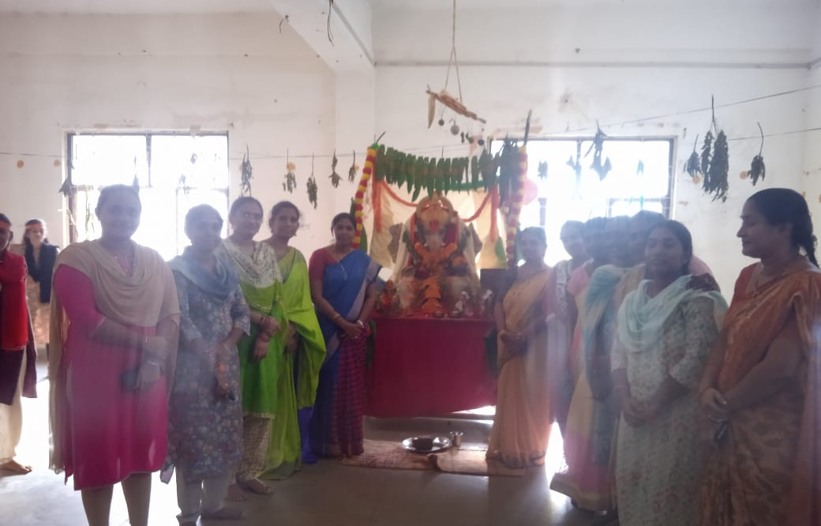

Bathukamma Day celebrations

As a part of as a part of part of creative club activity TTWRDC(G) celebrated Bathukamma festival, and that occasion students prepared Bathukamma by using different materials like vegetables leaves and their and their creativity resemblance resembles Atif nature. By encouraging like this student will get the knowledge to make different types of Bathukamma not only by using flowers given also the use local material to make Bathukamma.

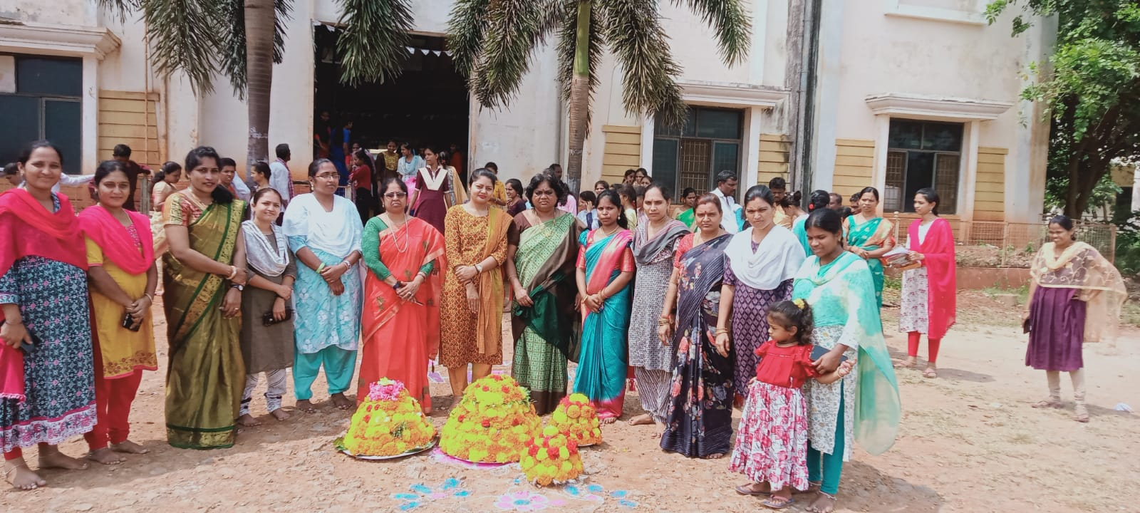

Paper Flower Bouquet making
A bouquet of flowers can be just the thing to show someone you care, to commemorate a joyous occasion. Going to the extra effort to assemble the bouquet yourself can also save your money while allowing you to personalize the gift. Whatever the event, whoever it is for, with a few tips and some healthy blooms, you'll soon create a bouquet that no one will want to throw away. So, with craft paper students prepared four Flower bouquets, and they are used for college occasions. The procedure step by step was demonstrated to all the young learners. They are Pretty, inexpensive and long-lasting.

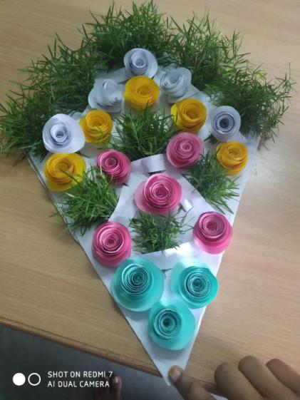

CREATIVE CLUB
PREPARING LEAF PLATES

- Arts and crafts involve making things with one’s own hands which enhances their creative thinking, artistic skills.
- Students will be provided the materials required and encouraged to involve.
- The purpose of Creative Club is to make College environment more creative and interesting.

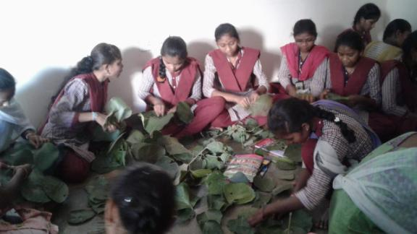

Art-Paintings
Drawing is the simplest type of visual art. It only requires a drawing tool, such as a pencil, and a surface, such as paper. By creating lines, there is shape. Details will make the drawing look more realistic or complex. By adding visual texture, perspective, or color, it becomes an illustration.

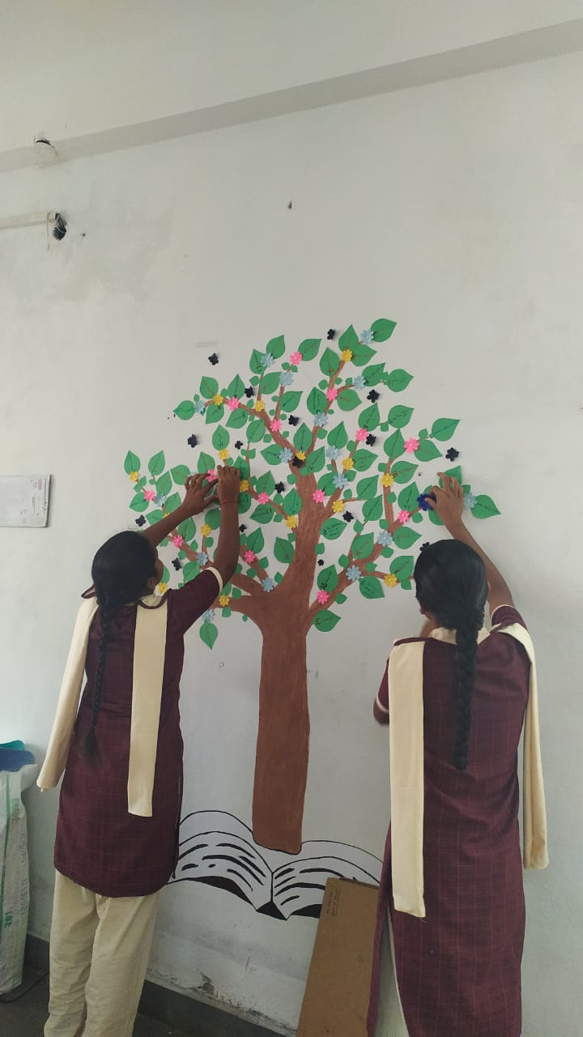

Paper Flower Bouquet making
A bouquet of flowers can be just the thing to show someone you care, to commemorate a joyous occasion. Going to the extra effort to assemble the bouquet yourself can also save your money while allowing you to personalize the gift. Whatever the event, whoever it is for, with a few tips and some healthy blooms, you'll soon create a bouquet that no one will want to throw away. So, with craft paper students prepared four Flower bouquets, and they are used for college occasions. The procedure step by step was demonstrated to all the young learners. They are Pretty, inexpensive and long-lasting.

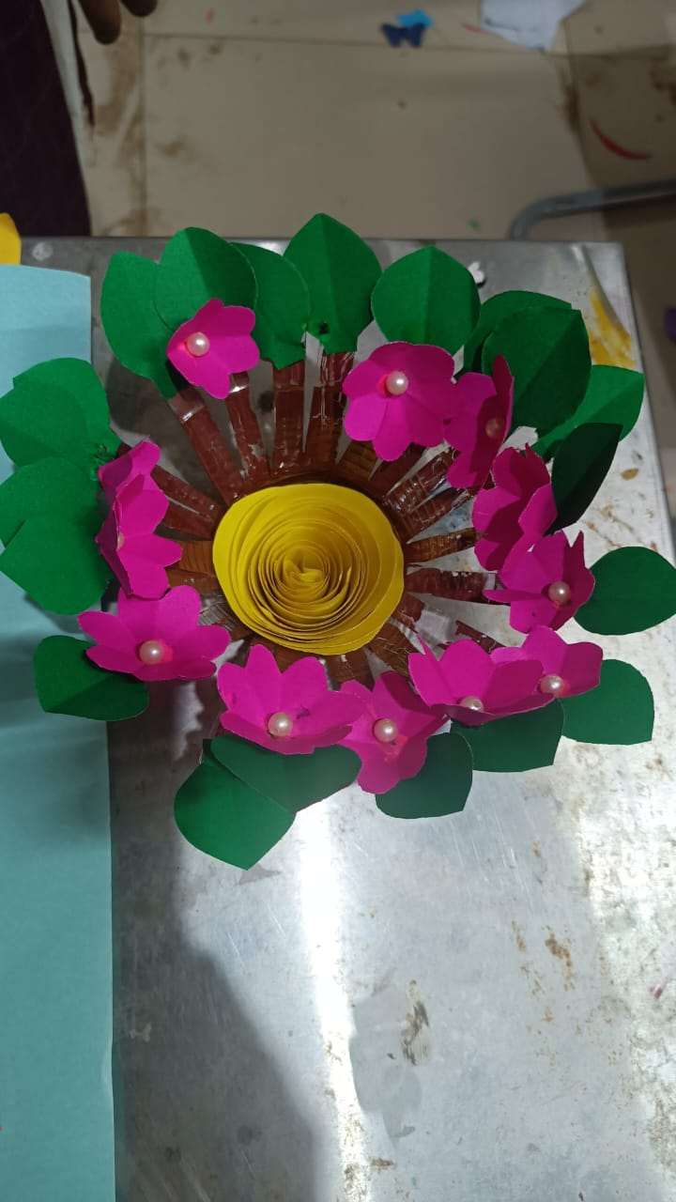

WALL HANGINGS
As a part of Creative club activity students prepared Wall hanging by using craft papers For this they used different craft papers and made into different shapes of flower In this club Students are participating activily.

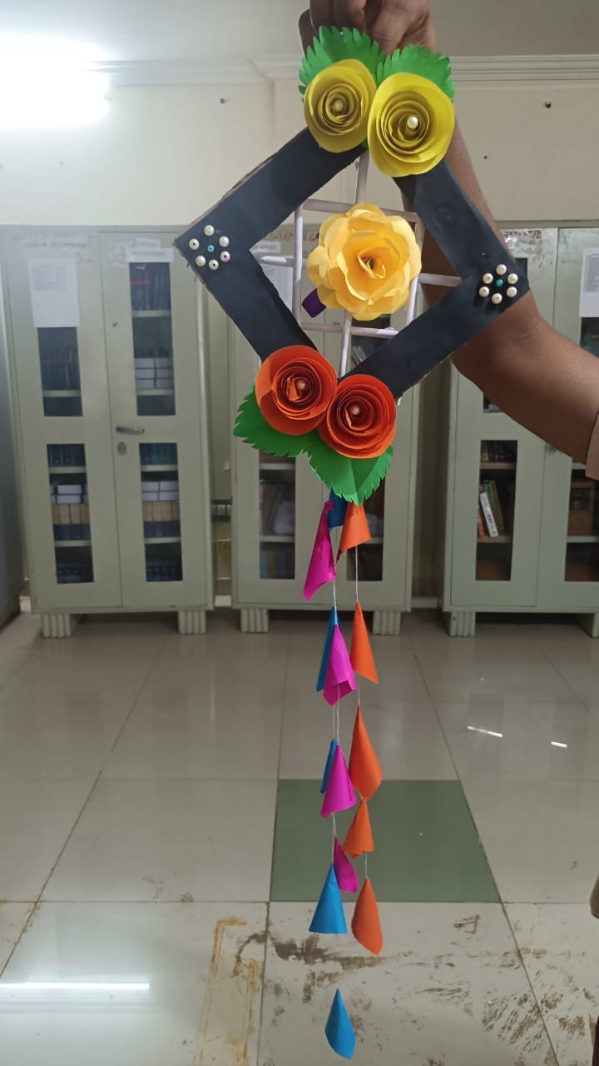

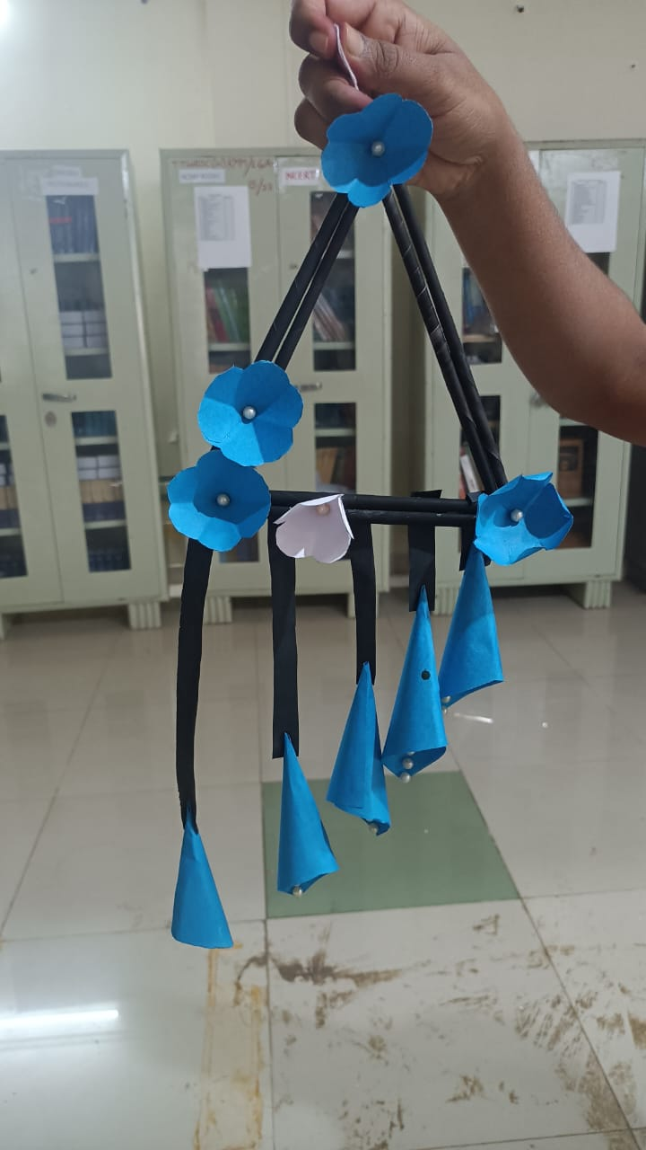

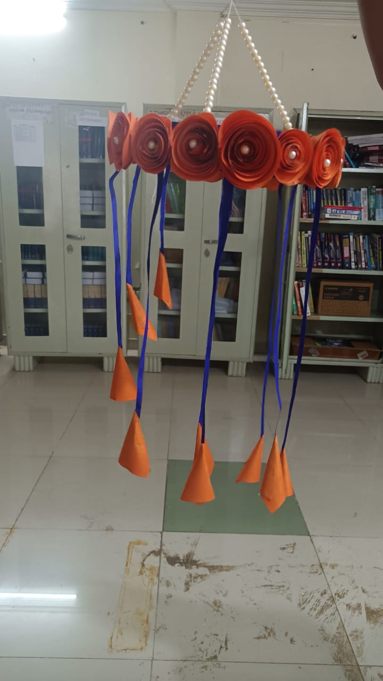

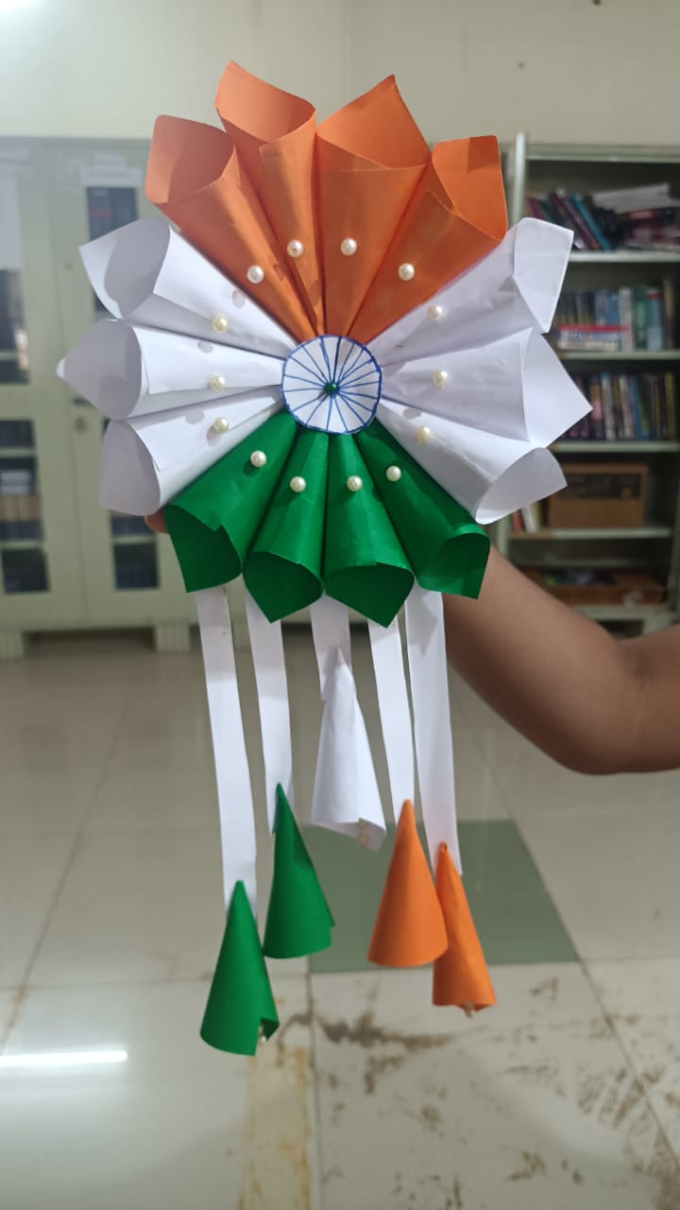

WALL HANGING
This craft is made by M. Akhila mpcs 3rd year this craft is nothing but paper crafting it is making of craft using paper as paper is relatively in expensive readily available and easy to work the craft Here is wall hanging

